April 9th ( Eng I/II and US History Sub 1)
7:30 – 8:00 | 1st period (30 min)
8:05 – 9:45 | Testing (100 min)
9:50 – 10:30 | 2nd period (40 min)
10:35 – 11:05 | 3rd period (30 min)
11:10 – 12:35 | 5th period (85 min)
11:10 – 11:35 | A Lunch
11:40 – 12:05 | B Lunch
12:10 – 12:35 | C Lunch
12:40 – 1:10 | 4th period (30 min)
1:15 – 1:45 | 6th period (30 min)
1:50 – 2:25 | 7th period (35 min)
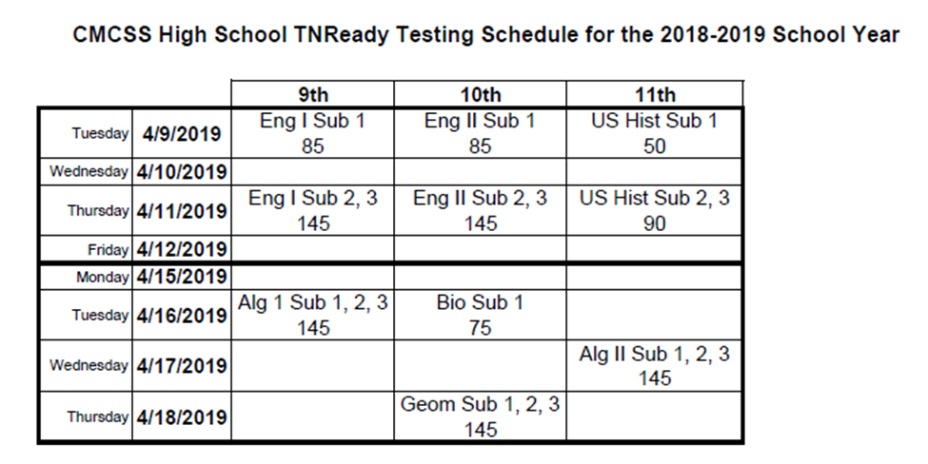

April 11th ( Eng I/II and US History Sub 2,3)
7:30 – 8:00 | 1st period (30 min)
8:05 – 10:55 | Testing (170 min)
11:00 – 11:20 | 2nd period (20 min)
11:25 – 12:50 | 5th period (85 min)
11:25 – 11:50 | A Lunch
11:55 – 12:20 | B Lunch
12:25 – 12:50 | C Lunch
12:55 – 1:15 | 3rd period (20 min)
1:20 – 1:40 | 4th period (20 min)
1:45 – 2:05 | 6th period (20 min)
2:10 – 2:27 | 7th period (17 min)

April 16th ( Algebra 1 Sub 1,2,3 testers ONLY) |  | April 16th ( Biology Sub 1 and non-testing students)
7:30 – 8:00 | 1st period (30 min) | 7:30 – 8:00 | 1st period (30 min)
8:05 – 10:55 | Testing (170 min) | 8:05 – 9:55 | 2nd/Testing (110 min)
10:55 – 11:25 | 4th period (30 min) | 10:00 – 10:50 | 3rd period (50 min)
11:30 – 12:55 | 5th period (85 min) | 10:55 – 11: 25 | 4th period (30 min)
11:30 – 11:55 | A Lunch | 11:30 – 12:55 | 5th period (85 min)
12:00 – 12:25 | B Lunch | 11:30 – 11:55 | A Lunch
12:30 – 12:55 | C Lunch | 12:00 – 12:25 | B Lunch
1:00 – 1:40 | 6th period (40 min) | 12:30 – 12:55 | C Lunch
1:45 – 2:25 | 7th period (40 min) | 1:00 – 1:40 | 6th period (40 min)
 |  | 1:45 – 2:25 | 7th period (40 min)

April 17th (Alg. 2) and April 18th (Geo) |  | Non-Testing Students April 17th and 18th
7:30 – 8:20 | 1st period (50 min) | 7:30 – 8:20 | 1st period (50 min)
8:25 – 11:25 | Testing (180 min) | 8:25 – 9:15 | 2nd period (50 min)
11:30 – 12:25 | 5th period (55 min) | 9:20 – 10:10 | 3rd period (50 min)
A Lunch testers to be sent during B Lunch |  | 10:15 – 11:05 | 4th period (50 min)
11:40 – 12:05 | B Lunch | 11:10 – 12:25 | 5th period (85 min)
12:10 – 12:35 | C Lunch | 11:10 – 11:35 | A Lunch
12:40 – 1:30 | 6th period (50 min) | 11:40 – 12:05 | B Lunch
1:35 – 2:25 | 7th period (50 min) | 12:10 – 12:35 | C Lunch
*During B Lunch, the gymnasium will be opened for overflow. |  | 12:40 – 1:30 | 6th period (50 min)
 |  | 1:35 – 2:25 | 7th period (50 min)

